Best Japanese Restaurant in Dubai

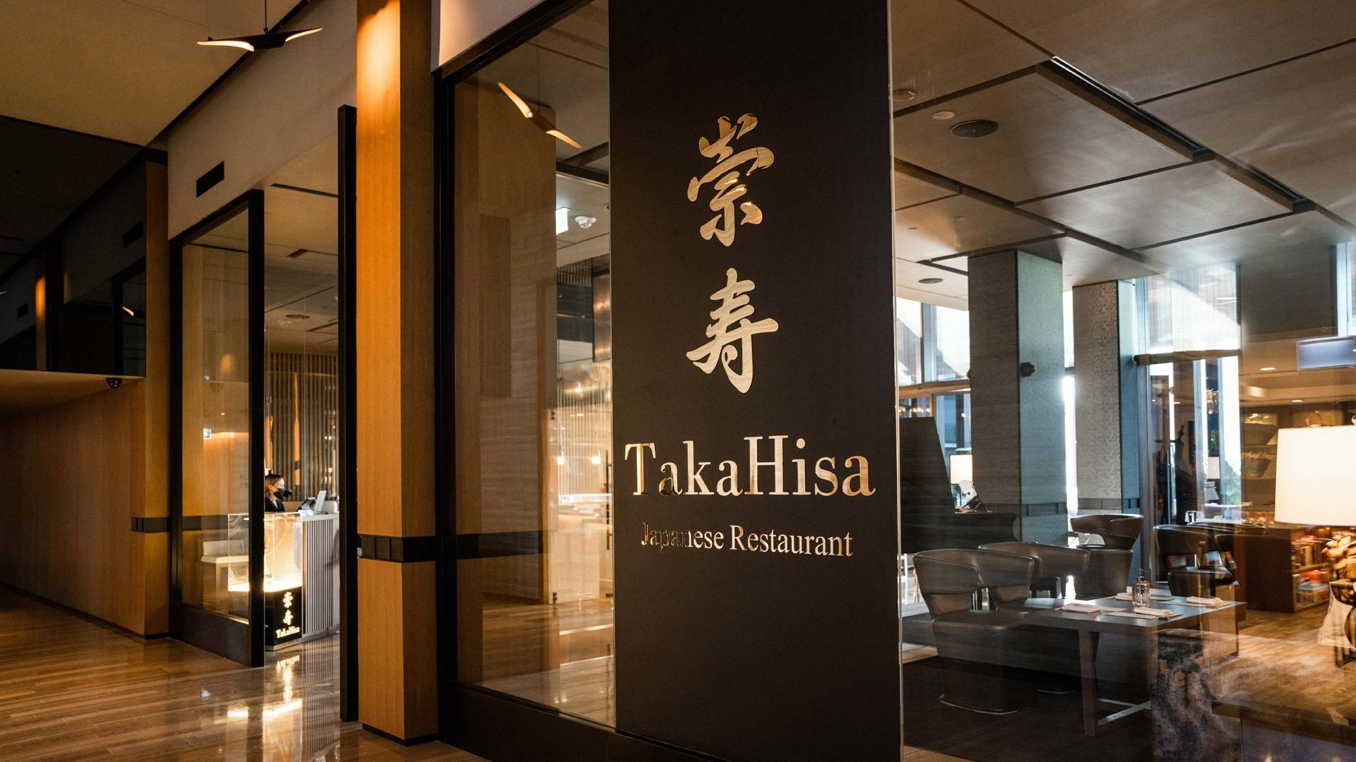

There is an uptrend for traditional sushi and bento dishes among the perfection-seeking Dubai population. If you are roaming around Dubai and looking for a real taste of Japan, the home-grown TakaHisa restaurant is a perfect option.

For most people worldwide, Japanese food culture is a mystery for them. There is an uptrend for traditional sushi and bento dishes among the perfection-seeking Dubai population. If you are roaming around Dubai, if you are looking for a real taste of Japan, the home-grown TakaHisa restaurant is a perfect option.

The best and most authentic Japanese restaurant in Dubai is TakaHisa. It serves top-notch Japanese food and is regarded as one of the city's top eateries. TakaHisa is a fantastic place to enjoy an exceptional blend of quality, authentic sushi and the best wagyu beef in the world and delivers the most sumptuous Japanese fine dining experience in the Emirates. This restaurant was developed with the help of the two executive chefs and their talented team. With more than 15 years of experience, both executive chefs are considered as the best in the world. The popularity of the restaurant can be explained by the fact that Hisao Ueda, one of the executive chefs, was awarded a UAE Golden Visa this year. It is regarded as Dubai's best Japanese restaurant because of this.

The Japanese restaurant TakaHisa was visited by the Crown Prince of Dubai. The restaurant offers top-notch seafood from Toyosu Market and "A5 Kobe beef," the finest wagyu brand in the world.

The TakaHisa staff is committed to serving the best Japanese food while giving customers a memorable experience that will popularise authentic Japanese food in the United Arab Emirates.
The inside of the restaurant has been tastefully furnished to encourage good relaxation for patrons. The views from this restaurant's exterior are likewise wonderfully tranquil; they will let you forget about everything else and divert your attention from your busy life's difficulties. This restaurant offers great and considerate service.

